ADTA-DAST 5900/5750.501: Applied Natural Language Processing
Project Detailed-Design of the AI dialogue System for each significant dialogue flow
By:- Bhawana Rohile, Sarika Gaind, Aamir Omar

Main flow: Default Start Flow & System State Machine
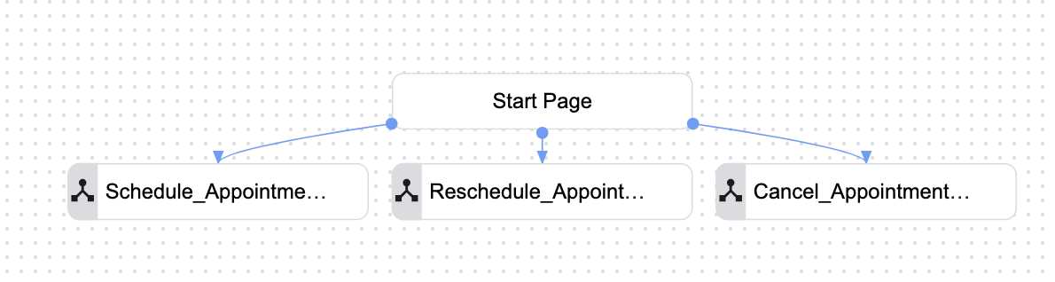
Our AI dialogue system has a very modular architecture. Each of our significant intents are separated by their respective flows. The system waits for initialization by the user (in a real-world applicable scenario this would be an incoming phone call) before identifying the users’ intent (whether to schedule, reschedule, or cancel an appointment). Once the system correctly identifies the intent, it routes the user to the correct sub flow and uses pages to navigate the sub flows and form parameters to collect the required information. Once all information is collected, the system will then garner confirmation from the user before confirming completion of the objective.

Sub flows & pages within each sub flow:
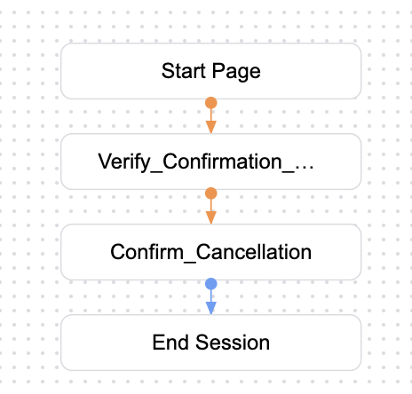
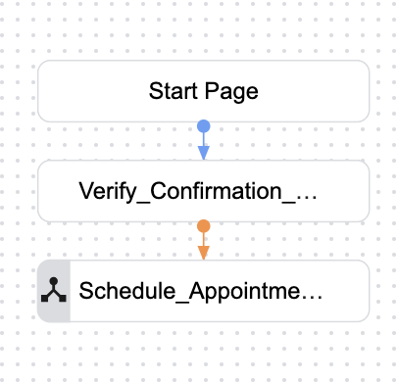
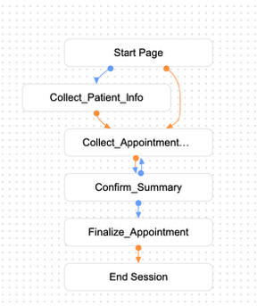
Each sub flow has pages to control the conversation flow and collect the necessary information.

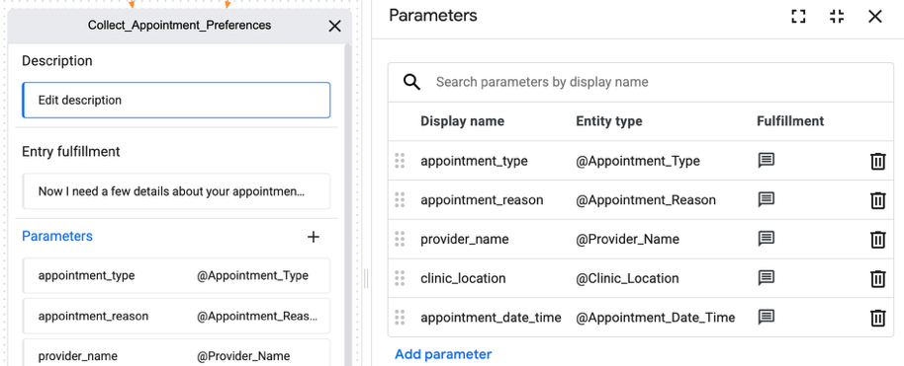
Form parameters:
The form parameters are utilized within the pages to ensure that the system has the required information required to complete the objective (intent of the user). In this example, the system is collecting appointment preferences to schedule an appointment.

